

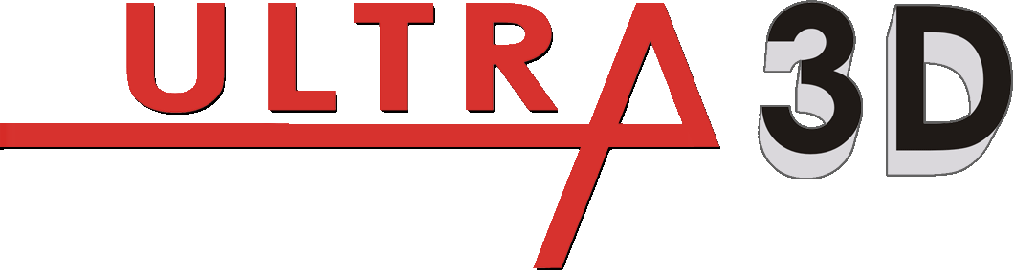
Series Wheel Aligner Installation Manual

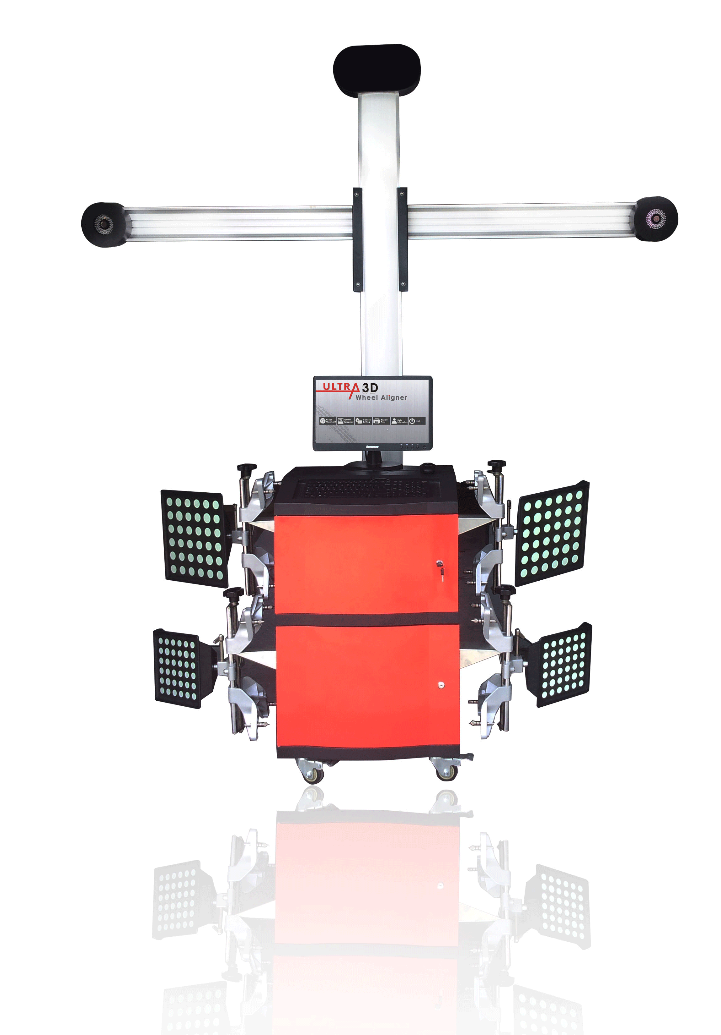

Trademark Information
PROTEC is a being registered trademark of Protec Equipment Canada in Canada. All other PROTEC trademarks, service marks, domain names, logos, and company names referred to in this manual are either trademarks, registered trademarks, service marks, domain names, logos, company names of or are otherwise the property of Protec Equipment Canada or its affiliates. In countries where any of the PROTEC trademarks, service marks, domain names, logos and company names are not registered, Protec Equipment Canada claims other rights associated with unregistered trademarks, service marks, domain names, logos, and company names. Other products or company names referred to in this manual may be trademarks of their respective owners. You may not use any trademark, service mark, domain name, logo, or company name of Protec Equipment Canada or any third party without permission from the owner of the applicable trademark, service mark, domain name, logo, or company name. You may contact Protec Equipment Canada by visiting us website, to request written permission to use Materials on this manual for purposes or for all other questions relating to this manual.

Copyright Information
All rights reserved by Protec Equipment Canada. No part of this publication may be reproduced, stored in a retrieval system, or transmitted in any form or by any means, electronic, mechanical, photocopying, recording or otherwise, without the prior written permission of Protec Equipment Canada. The information contained herein is designed only for the use of this unit. Protec Equipment Canada is not responsible for any use of this information as applied to other units.

Neither Protec Equipment Canada nor its affiliates shall be liable to the purchaser of this unit or third parties for damages, losses, costs, or expenses incurred by purchaser or third parties as a result of: accident, misuse, or abuse of this unit, or unauthorized modifications, repairs, or alterations to this unit, or failure to strictly comply with Protec Equipment Canada operating and maintenance instructions.

LAUNCH EQUIPMENT CANADA INC. shall not be liable for any damages or problems arising from the use of any options or any consumable products other than those designated as Original Protec Equipment Canada Products.

Precautions
- Please read the User’s Manual and the Installation and Parts Manual carefully before operating Ultra3D.
- Only the qualified technician can operate the Wheel Aligner.
- The operator must have knowledge of computer application and basic theory of wheel alignment.
- The power voltage of Ultra3D is AC110~240V±10% 50±1Hz / 60±1Hz. The power outlet must be a Three PIN socket and its earth pin must be well grounded. If the power voltage is not stable, please purchase and use AC voltage stabilizer.
- Ultra3D is operated with image sensing; by analyze target images recorded by high-resolution video camera. Avoid reflect Infrared light or direct sun light to the targets.
- Ultra3D is high precision equipment; special care should be taken during installation and operation to prevent the casing from being distorted and the internal parts from being damaged.
- Install the lift according to the lift specifications before installing Ultra 3D. Check the lift regularly for fixedness and levelness to ensure personal safety and correct measurement. Remove the obstacles around the lift for convenient operation.
- Don’t place Ultra3D on a vibrated object or an oblique surface. Avoid direct sunlight and moisture.
- Avoid splashing water on the surface of Ultra3D, for it may cause permanent damage to the system.
- The targets are major components for wheel alignment, be careful in storage or operation. Clean the dirt with neutral detergent or ethanol.
- Accurate calibration is made during manufacturing, and the design doesn't require calibration work for a few years, install Ultra3D according to the user manual. Do NOT move the column, open or adjust cameras, or else the warranty is expired automatically, and end user will bear the cost of damage.
- Video cameras are high precision parts; the filters shall be kept clean.
- Turn off the power after operation. Check all bolts and parts after maintenance, and tighten the slackened bolts and parts in turn for safety.
- Check the packing list before installing. Do not hesitate to contact LAUNCH EQUIPMENT CANADA INC. or its distributors for any questions.

General Safety Instructions

The chassis measurement system may only be used to measure vehicle axles according to specifications.

Only trained professional may operate the system.

Safety equipment may not be removed and/or disabled.

Repairs may only be performed by trained customer service personnel. Arbitrary modifications of the system exclude any liability by Protec Equipment Canada for any resulting damages.

Any work on the electrical installation may only be performed by electricians.
The wheel aligner system may not be operated in explosion- prone surroundings.
The operator must provide appropriate fire protection measures at the measuring platform. In particular, any flammable or self- combusting items (such as cloths soaked in solvents or oil) and fluids, or foreign items and other ignition sources, should not be stored in the tool trolley.

Obligation by the operator to be considerate and avoid negligent acts:

The equipment was designed and constructed with consideration to required harmonized standards, as well as additional technical specifications. It therefore corresponds with the current state of technology and provides the maximum standard in safety during the operation.

The machine safety, however, can only be implemented during the operation, if all of the required steps have been taken. The operator of the machine has the obligation to plan these actions and check their compliance.

The operator must specifically verify that:

• The machine is only used according to specifications.

• The machine is only operated in perfect operational condition and that the safety equipment is routinely inspected as to their operational condition.

• The necessary personal safety equipment for operating, maintenance and repair personnel is available and being worn.

• The operating instructions are always in a legible condition and are completely available at the machine location.

• The machine is only operated, maintained and repaired by qualified and authorized personnel.

• This personnel is instructed routinely in all pertaining questions of work safety and environmental protection, and knows the operating instructions, especially the safety instructions contained therein.

• All safety and warning labels attached to the machine are not removed and are legible.

Concrete safety instructions and applied symbols

Concrete safety instructions are provided in the following operating instructions which will point out any unavoidable remaining risks during the machine operation. These remaining risks contain hazards for:

Persons
Product and machine
The environment

Basic safety measures during normal operations:

The machine may only be operated by trained and authorized personnel who know the operating instructions and are capable of working with them!
Prior to switching the machine on, check and verify that:
Only authorized personnel are located within the working range of the machine.
No one can be injured when the machine is activated!
Check the machine for visible damages prior to use and verify that it is only operated in perfect condition! Report any problems immediately to the supervisor!
Prior to each operating start, check and verify that all safety equipment operates perfectly!

Basic safety measures during service and maintenance:

Adhere to the inspection and maintenance intervals specified in the operating instructions!

Block access to the work area of the machine to unauthorized personnel prior to performing maintenance or repairs! Attach or set up a warning sign that points out maintenance or repair work!

 Pull the power plug prior to any maintenance or repair work or switch off the main switch for the power supply and secure with a lock, if the power supply is installed.
The key to this lock must be in the hands of the person that is completing the maintenance or repair work! Only use perfect load suspension and lifting equipment when replacing heavy machine parts!

Properly dispose of environmentally hazardous lubricants, coolants or cleaning agents!

Working on the electrical equipment:

Repairs on electrical equipment of the machine may only be performed by trained electricians!
Electrical equipment must be routinely inspected!
Re-attach any loose connections!
Immediately replace damaged lines/cables!
Always keep housings of electrical equipment closed! Access is only permitted for authorized personnel with key/tools!
Never spray the housing of electrical equipment with a hose when cleaning!

Observe environmental regulations:

The legal regulations for waste prevention and proper recycling/disposal must be adhered to for all operations on and with the machine.
Especially during installation, repair and maintenance operations, water-polluting materials, such as:
Lubricants and oils - hydraulic oils - coolants.

Solvent-containing cleaning liquids may not pollute the ground or reach the sewage system!!
These materials must be stored, transported, collected and disposed of in suitable containers!

Chapter 1 Introduction

1. 4 Function and feature
- All new three dimension computer visual measurement: adopted high performance camera to automatically detect the alignment parameter. The equipment was calibrated at production, does not need on-site calibration at installation.
- Complete parameter measurement: Capable of test of front/rear toe-in, front/rear camber, thrust angle, caster, SAI/Kingpin, wheelbase, track (thread) etc. Can measure track width, wheelbase, etc. as show below:
- Electric component free target: no electric component or wiring on the target, which ensure the equipment to be more convenient and durable.
- Extremely simplified test procedure.
- Complete database: More than 20000 records of vehicle all over the world, and user can add data at will.
- Historical data storage for client management.
- Vehicle chassis adjustment indication picture
- Real-time help system.
- Data backup/restore, and update function.

1. 2 Tech Specs
alignment parameter | Accuracy | Range | Max measureable Range
Camber | ±2´ | ±2° | ±20°
Toe | ±2´ | ±2° | ±20°
Caster | ±4´ | ±10° | ±20°
Steering Axle Inclination | ±6´ | ±15° | ±20°
Thrust Angle | ±2´ | ±2° | ±10°
Display Accuracy: 0. 01˚ / 1’ / 0. 1mm / 0. 1inch

Caution:
- LAUNCH EQUIPMENT CANADA INC. preserves the right to change design without prior notification.
- The measure range can only be assured when operate the wheel aligner according to the user manual.

1. 3 Requirements on Surroundings
- Ambient temperature:0～50℃
- Relative humidity:≤85%
- Light condition: No direct Infrared light to the targets
- lift platform height difference: front/end height difference < 2mm

Chapter 2 Hardware Installation

2.1 Site Check List

2.1.1 Ultra3D+ Wheel Aligner
Check List | Requirement | Actually Measured Result
Installation Height of Column ( Distance from ground to top end of the column) | 2810mm | If the actually height available is less than required, can cut the column to suit the actually needs.
Alignment Platform Height ( Distance from ground to Turntable Surface) | 0-1600mm | There might be up to 100mm difference depends on the size of wheel, wheel base, distance from left to right post(4 post lift)
Column Standard Distance(Distance from center of turntable to Column front surface) | 2200mm | -300mm to 300mm tolerance, difference in distance will result in change in measurement height.
Platform front/end height difference | <2mm | Big height difference will result in difficulty in doing pushing compensation.
Power Supply | AC 220V/110V 8A

2.1.2 Ultra3D Wheel Aligner
Check List | Requirement | Actually Measured Result
Installation Height of Column ( Distance from ground to top end of the column) | 2810mm | If the actually height available is less than required, can cut the column to suit the actually needs.
Alignment Platform Height ( Distance from ground to Turntable Surface) | 0-1600mm | There might be up to 100mm difference depends on the size of wheel, wheel base, distance from left to right post(4 post lift)
Column Standard Distance(Distance from center of turntable to Column front surface) | 2200mm | -300mm to 300mm tolerance, difference in distance will result in change in measurement height.
Platform front/end height difference | <2mm | Big height difference will result in difficulty in doing pushing compensation.
Power Supply | AC 220V/110V 8A
Installation Height of camera bar |  | According to actually Alignment Platform Height. Adjust the height by software target monitor status.

2.2 Determine installation position
2.2.1 Installation positioning
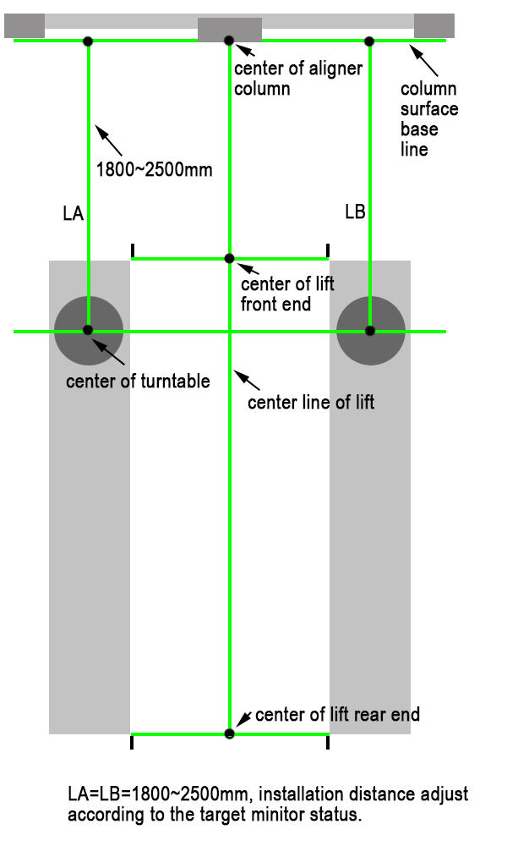
2.2.2 Installation procedure
      - Find Center Line of lift/ground test area.
      - Assemble the column and camera bar assembly, fit the column center to the center line
      - Find center of turntables
      - Measure the distance from turntables to column surface(front) base line, make sure both side are almost the same.
      - Confirm the installation position by compare the distance from turntable to camera at each side. (optional)
      - Connect computer, finish all the wiring and connection work, test run the alignment software.
      - Put a car on the lift/ground test area and mount the targets.
      - Switch to target monitor screen. Confirm the target images are in safe area and both side image are at similar height.
      - Test a few vehicles.
      - Confirm no more adjustment needed, drill holes ( the equipment comes with M16 bolts) and fix the column to the ground.

Note:
Ultra3D(+) is ok to work as long as the camera can see the targets. But at installation, its better to install the machine the correct way, so that when the vehicle driven onto the test area, the vehicle might not center and straight (always not center and straight), a nice installation would reduce the risk that some of the targets go off the camera range because vehicle position not straight.

Chapter 3 Wiring and Connection

2. 1 Ultra3D+ Wheel Aligner

2. 1. 1 Electronic Control Wiring Connection
Ultra3D+ Electronic Control Wiring Connection
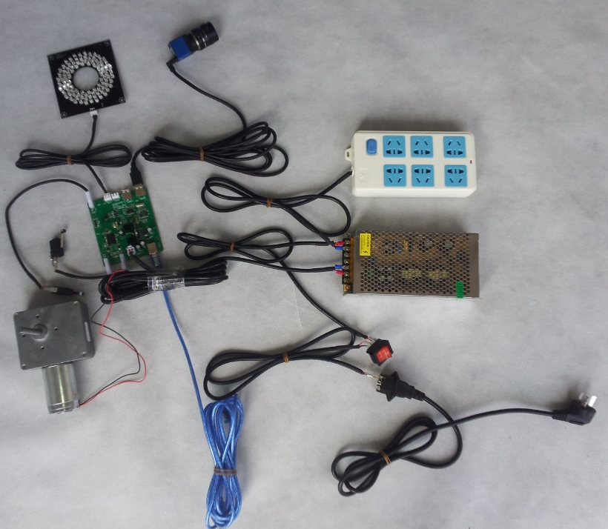
1
2
3
4
5
6
7
8
9
10
11
12
13
14
15
16
17
188
19

1. 3 Meter power cable | 2. Power plug | 3. Fuse plug
4. Power Switch Cable | 5. Power switch | 6. Switch power
7. Switch power in-line cable | 8. Power plug(6 pack) | 9. Camera(2 units)
10. Camera data cable (2 pcs) | 11. LED Board (2 pcs) | 12. LED Board power cable (2 pcs)
13. upper limit switch power cable | 14. limit switch | 15. lower limit switch power cable
16. Control board PCA | 17. Low voltage power cable | 18. Motor
19. Data bus

2. 1. 3 Control diagram
Ultra3D+ Control Diagram
Camera(Left)
LED PCA (Left)
LED PCA (Right)
Camera(Right)
Switch power

Control board PCA

Motor
Limit switch

Computer Host

Monitor

2. 4 Control board PCA
1) diagram
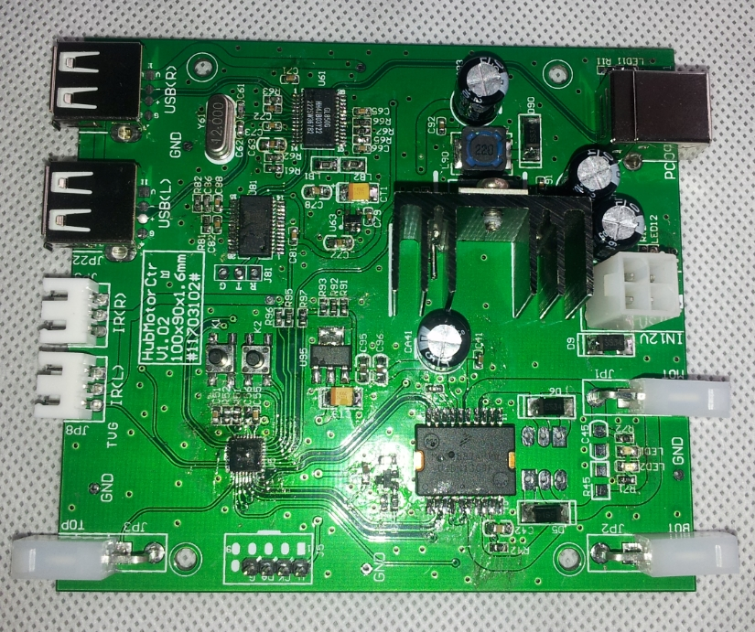
5
4
3
2
1
10
9
8
7
6
- Camera(Right) USB port | - Camera(left) USB port | - LED board PCA (right) power source
- LED board PCA (left) power source | - upper limit switch power source | - lower limit switch power source
- Motor power source | - Switch power inlet port | - Data bus port
- Manual rise/drop switch

Chapter 4 Target Monitor Explanation

At test run to confirm the installation position, the target monitoring screen of the software offers a standard of confirmation.

Caution:
- The wire connection shall be complete and the USB dongle well plugged onto the computer.
- Software switch to Normal Mode, otherwise won’t be able to retrieve image data from cameras.
- A vehicle shall be driven onto the lift/ground test area, and have clamps and targets mounted.

At [main screen], click [Wheel Alignment] to enter the [vehicle selection] screen, click [target monitoring] to enter target monitor screen.
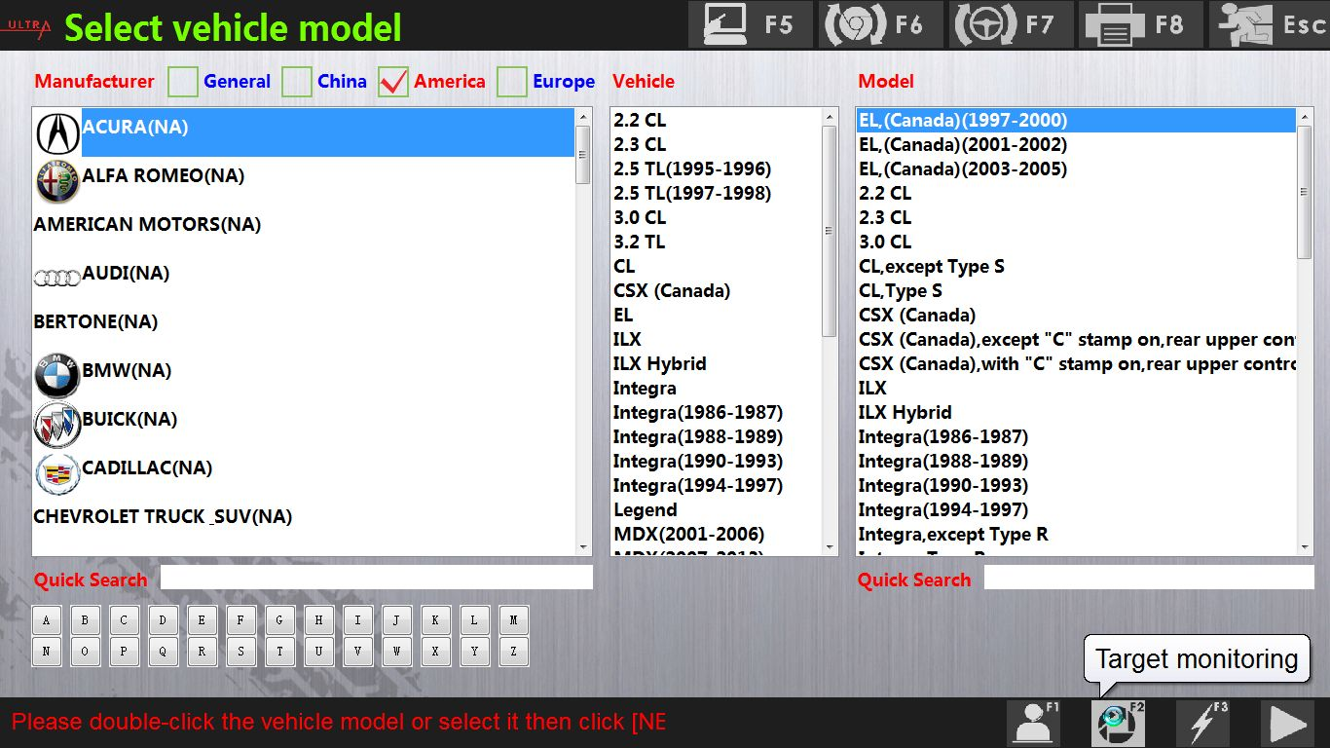

Standard target position as below,
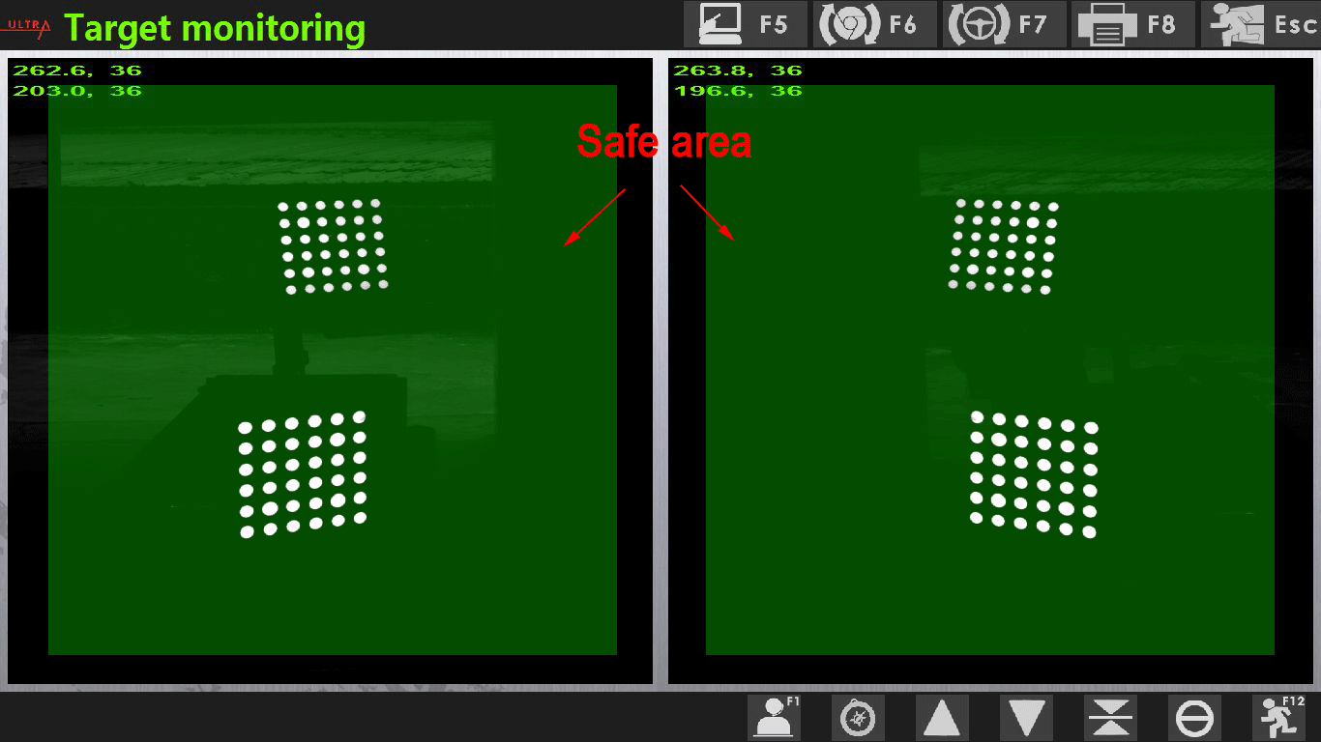
Other position explanation

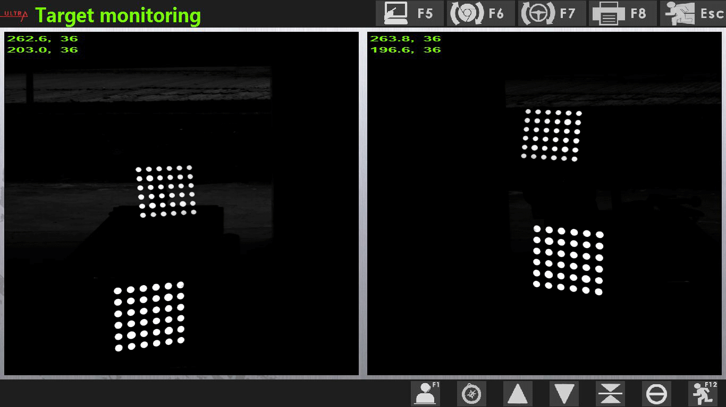
Left side camera height lower than the right side.

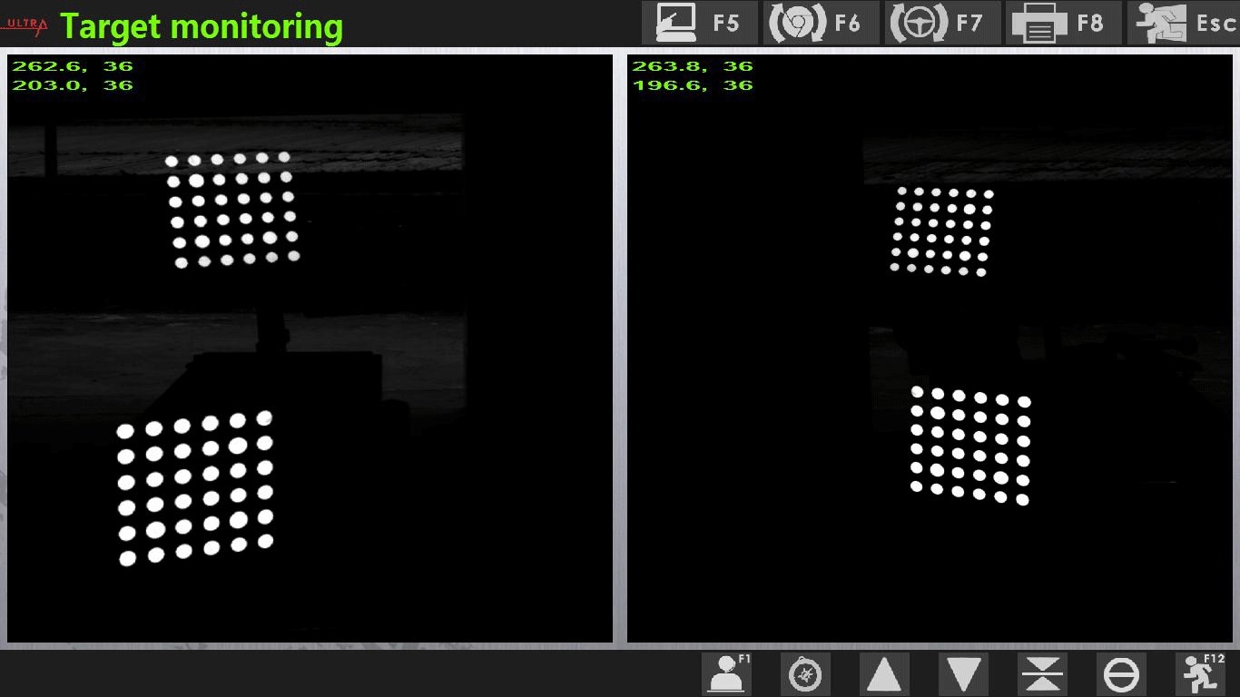
Left side closer to the turntable than the right side does.
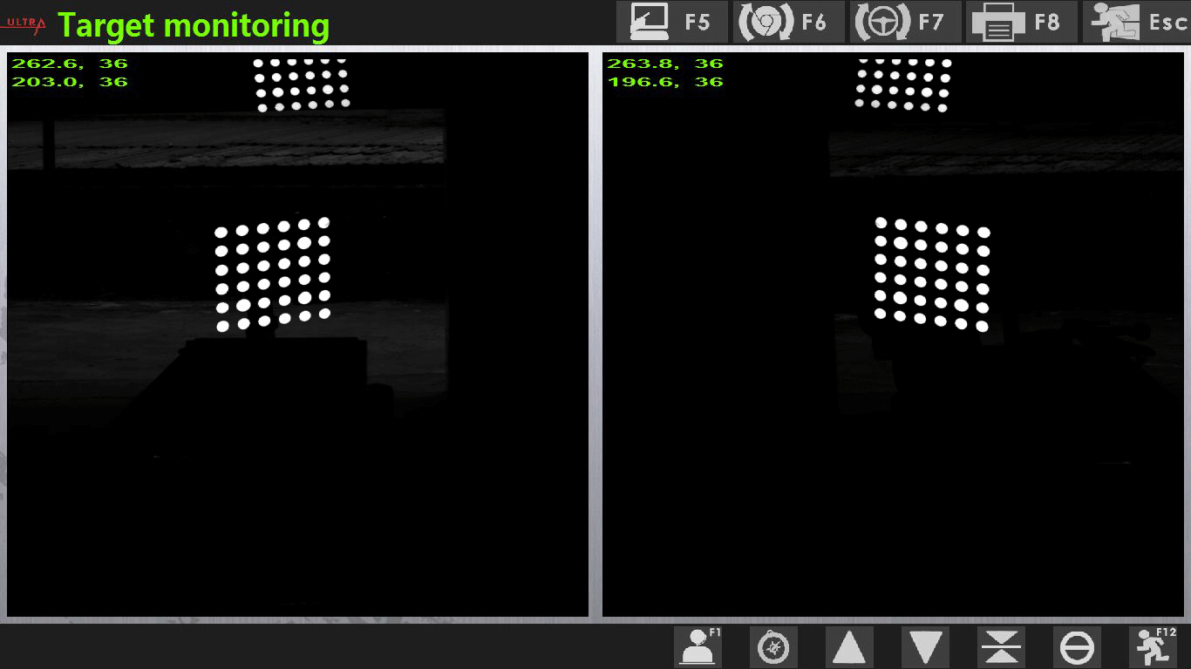
Ultra3D: camera bar installation height too low. (when the vehicle is on desired height/ground)
Ultra3D+: its not a problem.

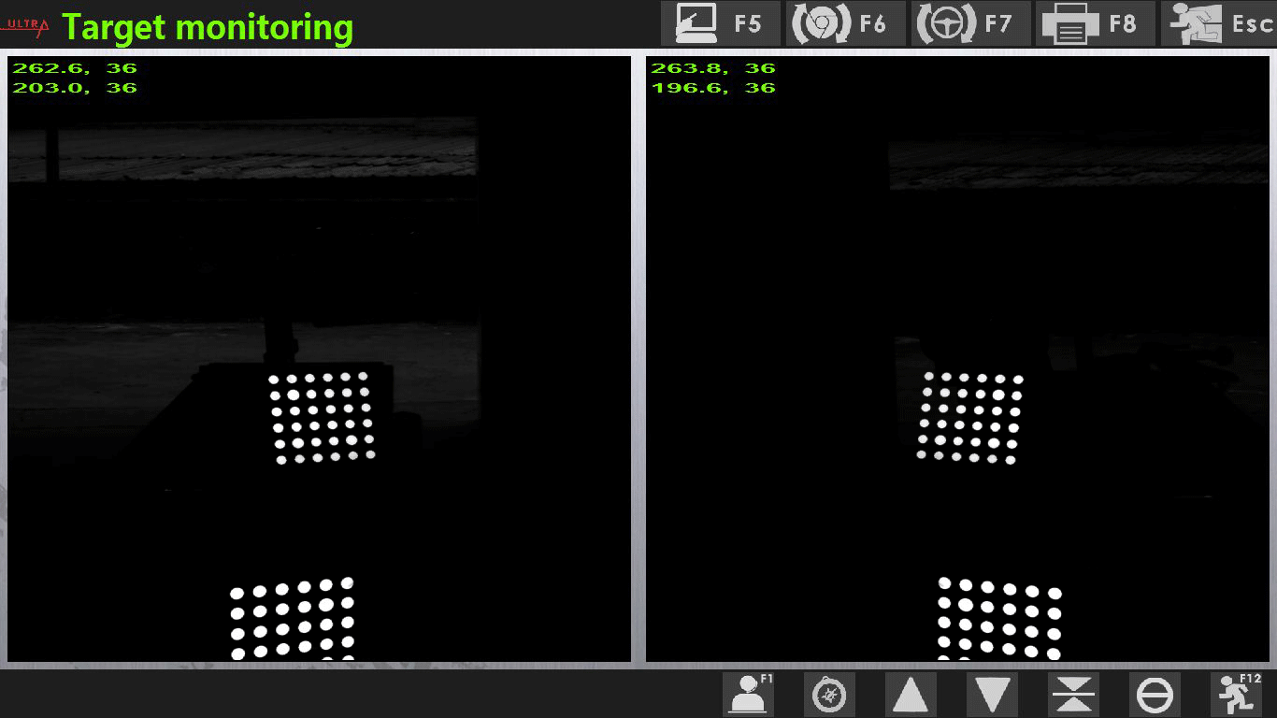
Ultra3D: Camera bar installation height too high. (when the vehicle is on desired height/ground)
Ultra3D+: its not a problem.
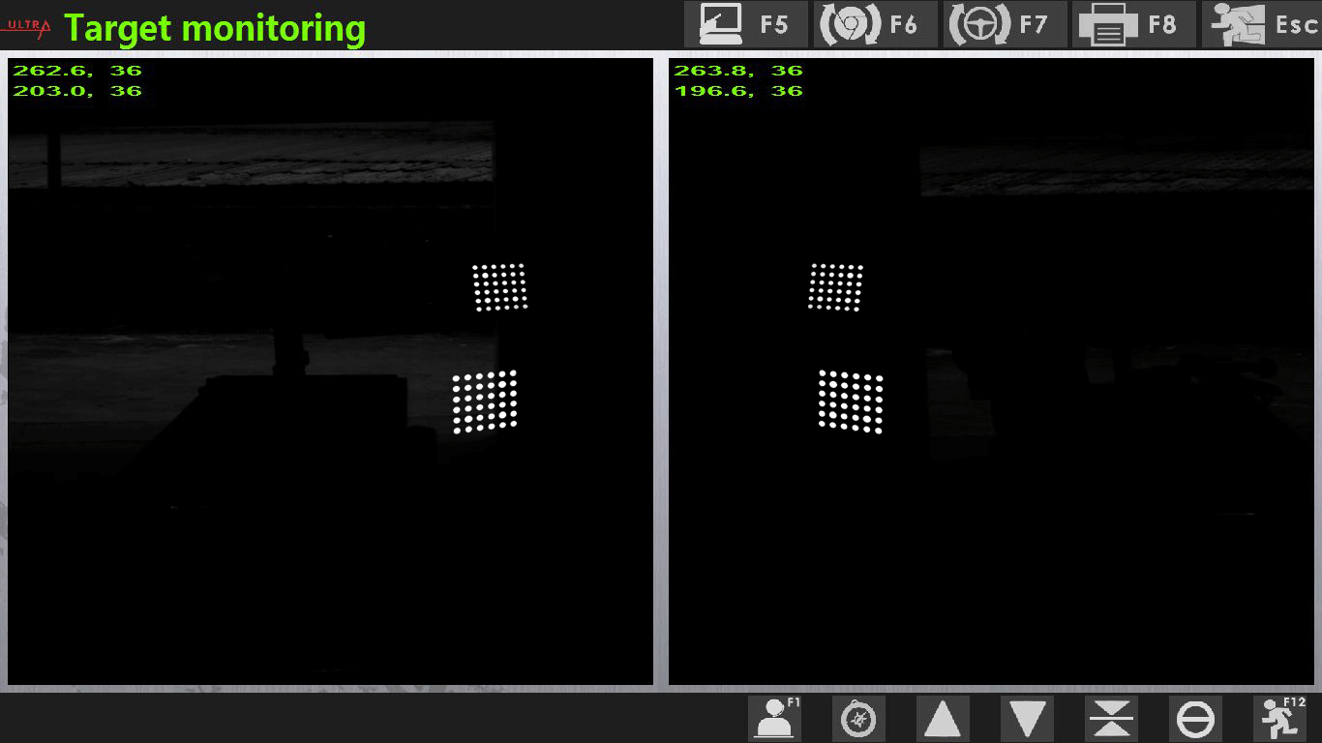
Column installation distance is too far.

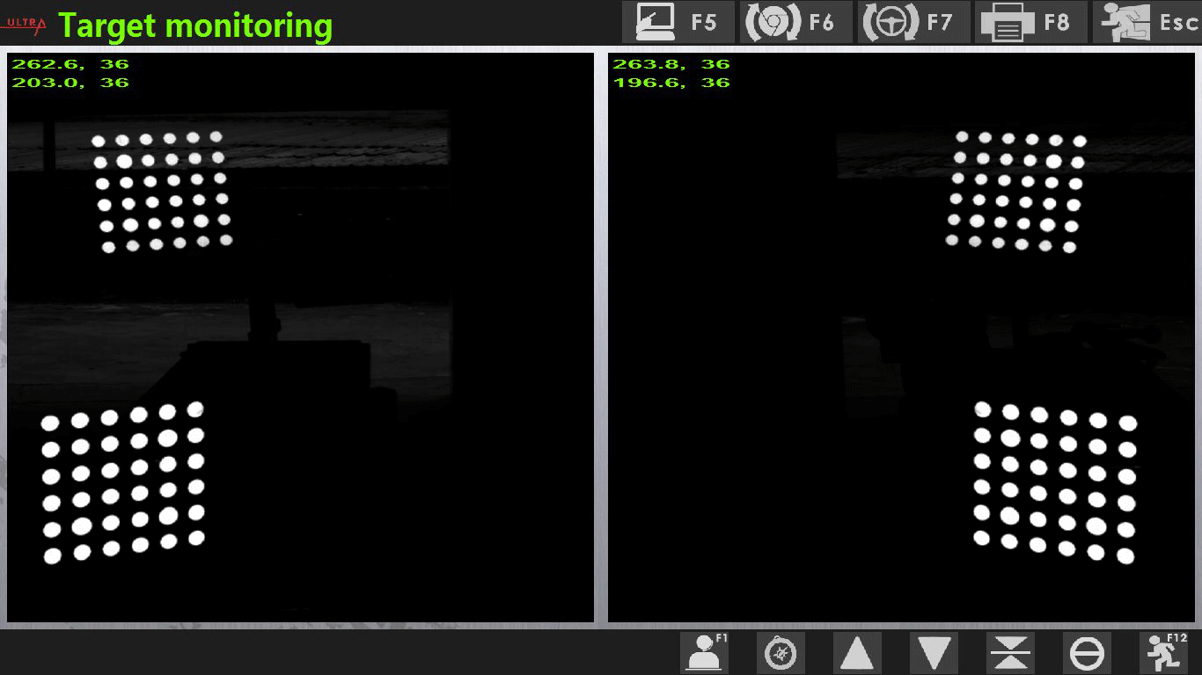
Column installation distance is too near.

